MREPC

Application Procedures And Guidelines

Enclosed herewith the SMG Promotional Grant application procedures and guidelines for your perusal.

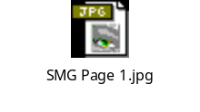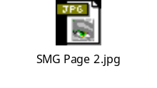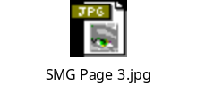

Before the Exhibition

As requested by MREPC, we need to apply the grant at least one month before the trade fair. The following documents have to be submitted at the initial stage of applying the SMG grant:
- Application form
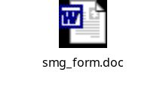
- The exhibition programs, brochure and estimated budget expenses that will be incurred for participating the trade fair.

During the Exhibition

- Hangs the “SMG Logo” at the exhibition booth to ensure that our company is promoting the SMG brand.
- Take some photos at exhibition booth to prove that we have attended & promoted the SMG gloves.
Things have to be careful when taking the photo at the exhibition booth:
- Must ensure that the date is shown on the photo.
- Must ensure that the name of the exhibition is being taken.
- Must ensure that the SMG banner is being taken and SMG logo is viewable from the photo.
- Must ensure that the Vinyl glove banner & Vinyl Glove Carton box are not shown on the photo.
- Do not hang the vinyl glove banner next to the SMG banner.

After the Exhibition

You have to fill in another report as per attached below.

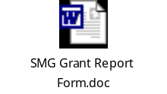

Below is the sample of the SMG Form, which was filled up by Mr. Jeff for your references.
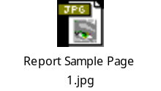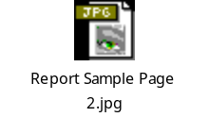

Companies are required to submit all relevant information to enable the application to be evaluated. All the reimbursement claims must be submitted within 3 months of undertaking the activity with original receipts and supporting documents.

Therefore, all the marketers need to submit all the original receipts to Mr Koo (Accounts Dept) immediately after you return back to Malaysia.

Should you require any clarification, please do not hesitate to contact me.

Your cooperation is highly appreciated.

